FurEver Care
They Deserve Forever Love
ReadMe — Pet Care Website (Responsive NextGen Website Development)

1. Project Overview
FurEver Care is a responsive, single-page-style pet care Website built for the Aptech TechWiz 6 competition (Theme: Pet Care). It brings together three kinds of users — Pet Owners, Veterinarians, and Animal Shelters / Rescue Volunteers — on a single platform where they can view pet profiles, care guidance, appointments, adoption listings, and pet products, all served from static JSON/TXT data (no backend/database).

2. Technologies Used
- Frontend: HTML5, CSS3, JavaScript (vanilla)
- Styling: Custom CSS with responsive layout (Flexbox/Grid); Bootstrap used only where noted
- Data Store: Static JSON files (no server-side storage, per SRS constraint)
- Other: HTML5 Geolocation API for location display, embedded audio/video for grooming and health tips
- IDE: Visual Studio Code

3. Folder Structure
Path / File | Purpose
index.html | Landing page — name entry + user category (Pet Owner / Veterinarian / Shelter)
pet-owner.html | Pet Owner dashboard: pet form, Pet Care sections, product showcase
veterinarian.html | Veterinarian profile, time slots, case studies
shelter.html | Animal shelter gallery, adoption filters, success stories, events
feedback.html / contact.html / about.html | Static support pages shared across user types
/css/style.css | Global responsive styling, fonts, colors, animations
/js/app.js | Core logic — routing between category pages, welcome message, clock/geolocation
/js/products.js | Loads product cards from products.json; sort/filter/search
/js/pets.js | Loads adoptable pets from pets.json; filter by type/age/breed
/data/products.json | Static product catalogue (food, toys, grooming, bedding, supplements)
/data/pets.json | Static adoptable-pet listings for the Shelter page
/data/vets.json | Static veterinarian profiles and time slots
/assets/ | Images, icons, and embedded audio/video used across the site

4. Site Navigation Flowchart
The diagram below shows how a visitor moves through FurEver Care — from the landing page, through the category chosen (Pet Owner, Veterinarian, or Animal Shelter), into that category's pages, and finally into the pages/features shared across all three.
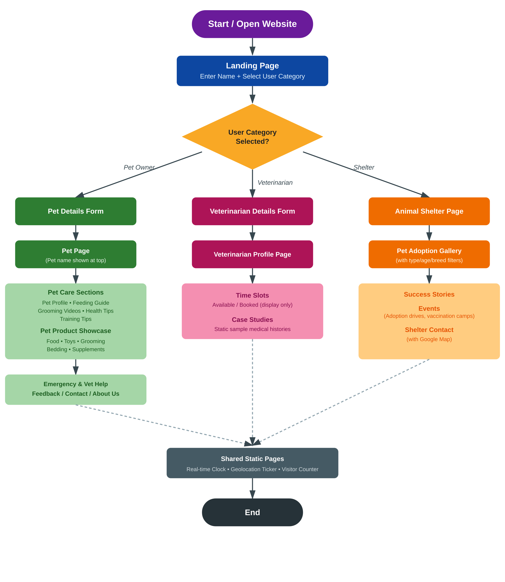

5. Features Implemented

5.1 Landing Page
- Accepts the user's first name and displays it persistently across pages
- Radio-button selection for user category: Pet Owner, Veterinarian, Animal Shelter / Rescue Volunteer
- Redirects to the relevant category page and menu based on the selection

5.2 Pet Owner
- Pet details form (name, species, breed, age) → dedicated pet page showing the pet's name at the top
- Pet Care Sections: Pet Profile, Feeding Guide, Grooming Videos, Health Tips, Training Tips
- Pet Product Showcase with categories (Food, Toys, Grooming, Bedding, Supplements), each card showing name, image, description, price, and a non-functional Buy Now button
- Sorting, filtering, and text search across products
- Emergency & Vet Help, Feedback (UI-only), Contact Us (with map), About Us
- Scrolling ticker for location, time, and updates; real-time clock; simulated visitor counter

5.3 Veterinarian
- Veterinarian details form (name, specialization, contact info, image) → profile page
- Display of booked/available time slots (display only)
- Static sample case studies / pet medical histories

5.4 Animal Shelter
- Gallery of adoptable pets (image, name, age, breed, short description)
- Client-side filter buttons by pet type (dog/cat/rabbit, etc.)
- Success stories of past adoptions
- Static event announcements (adoption drives, vaccination camps)
- Shelter contact details with Google Map embed

6. How to Run the Project
- Unzip the project folder.
- Open index.html directly in a modern browser (Chrome/Edge/Firefox), or
- Serve the folder with a lightweight local server (e.g. VS Code 'Live Server' extension) for correct JSON fetch behaviour, since some browsers block fetch() on file:// paths.
- No installation, build step, or database setup is required — all data is read from the /data JSON files.

7. Assumptions
- No backend or database is used; all information (pets, products, vets, adoption listings) is served from static JSON/TXT files as permitted by the SRS constraints.
- Forms (pet details, veterinarian details, feedback) capture and display data on the client side only — there is no persistent write-back to the JSON files.
- The 'Buy Now' button on product cards and the feedback form submission are intentionally non-functional, per SRS.
- Geolocation is used only to display an approximate location in the scrolling ticker; it is not stored or transmitted anywhere.
- Visitor counter is simulated (client-side) and resets on reload, since there is no server-side persistence.
- Sample data (pets, products, vets, case studies) is illustrative placeholder content created for demonstration purposes.

8. Known Limitations
- Data entered via forms is not saved between sessions (no local storage/back-end, per project constraints).
- The site is not connected to a real payment or appointment-booking system.

9. Credits
Developed for Aptech TechWiz 6 — Global AI-Based Tech Competition, Pet Care theme, based on the FurEver Care Software Requirements Specification (Version 1.0).

